University of Oxford Disability Lecture 2026
Dr Sarah Lewthwaite
Digital accessibility at the crossroads:
infrastructure, AI, and the future we build
8 June 2026

Greeting by Jordelle Akinola, University of Oxford Disability Advisor
Good evening everybody, and welcome. My name is Jordelle Akinola, and I'm the Staff Disability Advisor within the central University, in the Equality and Diversity team.
It's my pleasure to welcome you today to Oxford University's twelfth annual Disability Lecture. It's so wonderful to see so many people here in person, and also the number of people who have registered to attend online. I'd like to thank you all for making the time to turn up today. We are so pleased that this event has attracted interest, not just locally at the University and in Oxford, but also more widely across the world. We've had registrations from far and wide, which speaks to the importance of the conversations that we're about to have today.
The annual Disability Lecture is an important opportunity for us to come together as a community, and reflect on not only the progress of the support that's available to people within our community and people who support the disabled community, but also to deepen our understanding and continue to advance on meaningful and acceptable ways that we can progress in future. Each year, the annual Disability Lecture invites us to critically engage with the issues that are impacting people who are disabled. And today, this topic of AI invites us to consider equality, participation and belonging across the University and beyond. This year's topic, focusing on digital accessibility, is a topic that's central to us all, particularly at the University, but in our day-to-day lives as well. As we continue to embed digital technologies, including artificial intelligence, it makes us think about the everyday practices that we encounter, that we come up against, and also the opportunities and challenges that these present if we don't think about inclusion from the start. Ensuring our digital environments are inclusive is not simply a technical challenge, it's a collective responsibility. It asks us to reflect on whose experiences are recognised, whose needs are prioritised, and how we can design systems that enable everyone to fully participate and succeed.
So before we go ahead, just a few notes on housekeeping. We're not expecting a fire drill today. If the alarm does go off, we have emergency exits situated to my right and also highlighted at the back of the theatre. There will be British Sign Language interpretation throughout the session, as well as for the Q&A section afterwards. We are trialling automatic captioning this year, and it would be great to have your feedback after the lecture about this. Toilets are located outside of the lecture theatre and to the right. And if anybody would like any support, please do let one of the stewards know, or myself. We will have a Q&A session afterwards, both in person and online. So please feel free if you're online to use the Q&A session. We will be having people supporting that. Assistive listening is available for your Auracast if that's needed today. And we also have a quiet room in Lecture Room 6. Soft drinks will be served at the end of the lecture. And in two weeks' time, we will have an accurately captioned podcast, videocast and transcript published online. The Q&A session will not be recorded, just in case anybody has any concerns about that.
So before I hand over to the Vice Chancellor, I just wanted to thank the Vice Chancellor for coming today, Professor Irene Tracey, for having such strong leadership for our University. AI in its use is so important both to students but also for staff who are supporting students, and it's embedded in our day-to-day lives. And I just want to thank you for being here today to open for us. So without further ado, Professor Irene Tracey.

Introduction by Professor Irene Tracey, Vice Chancellor of the University of Oxford
Well, thank you very much. I'm absolutely delighted to be here. So thank you to you for including me again on what is always a wonderful calendar event. (I have to say the captioning is working really well. I think better than last time, if memory serves. So that's good, moving in the right direction.)
So it's just been said, this is our twelfth Annual Disability Lecture. This very much now marks the calendar, does it not, as we come towards the end of this term and another academic year. And it is the fourth time that we've had British Sign Language. So again, really great to have that. And I see 114 people, 120 now, are joining us online. So again, great to have so many people participating there.
This event doesn't happen by magic. It is organised by our wonderful Disability and Neurodivergence Advisory Group, as well as the Equality and Diversity Unit. And so I'm really grateful to all of them for the work they do, not just in organising this lecture, but for the work that they do throughout the year. So on your behalf, I'd like to acknowledge and thank them for the work that they do in many aspects. But again, tonight, we're focusing on specifically around the disability side, so thank you very much to everybody involved with that.
And of course, we're in our new Life and Mind Building. I've got to stop saying it's new because we're still almost a year now academically here. But I hope for those of you who've not been here before, you really do enjoy what is one of our new spectacular new buildings and spaces. And certainly I know for the reception afterwards, you'll get to see a little bit more and experience it. Sorry for those online, you'll miss out. Another time.
So as mentioned, this topic today is all about digital accessibility. It goes without saying that as a university intensive in our teaching and our research, it all centres and is very dependent on the digital offer. And of course, we're always trying to think about how we can improve that and how we can make it, again, fit for what we're trying to deliver for our students and for our staff and to deliver on that research. I mean, it's just part of the fabric, is it not, of the way we do our business? And that's been something that has accelerated over the past few decades. And certainly each year, I just feel it accelerates more and more.
And of course, AI has come in and just sort of thrown all the cards up again in the air. So largely, it's something that, of course, we just take for granted, and it works, and people behind the scenes are working to make sure that it works. And unfortunately, like things that we take for granted, you only really notice it when either we get a cyber-attack or it fails or there's some sort of system breakdown, and then we realise just how dependent we've become on it. And that's quite rare for most of us, but it is the case – and that's why tonight's topic is so important – that for many people, it fails more regularly than those experiences that we might have irregularly through some of those extreme circumstances. And again, that's a real problem for us. And I think making that more aware and then working out what it is we need to do to mitigate that is really important.
I've been given some really sobering statistics here, which I'm going to share with you. So a 2025 audit looked at the home pages of the top one million websites on the internet and found that 96 percent of these had accessibility errors, which is shocking. On the 2026 Silktide Index for accessibility, our own university websites scored only 76 percent. And, as you know, the top university in the world, we like to be at 100 percent in everything we do. Now, that's good. It's gone up from 64 percent in 2024. So we're moving in the right direction, but that's a big margin to go. And I know that David and others will work hard in the team to make sure that we can reach that 100 percent and will be challenged, I know, tonight in that regard.
Of course, the AI arrival is great. And that is helping in many regards, both in terms of where things have failed before. But I think we all know as we've started to experience it more and more, and we're bringing it into the lifeblood of the University and making sure that we're all trained and our students are trained how to use it well, how to use it ethically, how to understand its problems, what we're all experiencing and unmasking is just how many biases there are in there in terms of algorithmic choices and decision points, and that particularly not being informed from the lens of what we're here tonight to think about in terms of failure for colleagues who are finding that the digital offer, and notably AI, whilst being beneficial, is bringing in some of these biases and ways of handling data that do not meet the need for our colleagues with disabilities.
So here, of course, we want to be at the forefront of our research and we want to embed AI, as you know, and I've been championing that, so we can't put our heads in the sand and hope that it will go away. It's here and of course, it's great in many other aspects, particularly the research. And of course, we're generating the new AI. Our researchers are contributing to some of those new ways that we think about the ethics and the framework and the philosophy, but it's the algorithms as well. So we have a real opportunity here, not just to benefit from AI in terms of the research, and to of course make sure that we are responsible in terms of how we equip our students, but we're shaping the very tools. And again, I think this conversation is really timely for us, and maybe collaborations that we can forge with our wonderful speaker tonight in terms of how we can help shape those algorithms, shape those platforms better so that they meet the need. And we will do that and we will be relentless in making sure that it does not have that negative impact also on our marginalised communities.
So tonight, as you know, we're very, very honoured and delighted to host Dr Sarah Lewthwaite, who is the Principal Research Fellow and Co-Director of the Centre for Research and Inclusion at the University of Southampton. I was just apologising to her for having poached her Vice Chancellor, who's now joined my team as the Pro Vice Chancellor in Planning, Resource and Allocation. So we're delighted to have Mark with us. Sorry about taking him away!
Sarah has spent her research career focusing on higher education, the sociology of accessibility and inaccessibility, pedagogies of accessibility and the student experience. She is a UK Research and Innovation Future Leaders Fellow, which is a really, really impressive thing to get because they're very competitive. And in that role, she leads the major Teaching Accessibility in the Digital Skill Set project. Her work prioritises participatory research methods and the use of disability theory, with new technologies as a basis for promoting inclusion in policy and practice. How fantastic is that, and how lucky are we to have you here tonight?
An article in the Times Higher Education earlier this year, which I encourage you all to read, on why digital accessibility is a leadership issue for universities, demonstrates that this is a central test of institutional quality. Accessibility should not be perceived as a compliance risk, but rather as a catalyst for international inclusive leadership. And I believe, and I'm sure, your talk tonight is going to walk us through and take us to the crossroads in digital accessibility, positive routes for action for individuals and institutions. So I shall be taking active notes.
So please join me in welcoming Dr Sarah Lewthwaite to give our Disability Annual Lecture.

Dr Sarah Lewthwaite: Digital accessibility at the crossroads
So thank you very much, everybody, and great thanks to Professor Tracey for her very warm welcome and warm words. And thank you all for coming. I didn't know I had so many friends here in Oxford, but I'm feeling very welcome, so thank you. And thank you also to the Disability and Neurodiversity Advisory Group and the Equality and Diversity Unit for this fantastic event.
I'm really excited to be here. I'm here to talk about digital accessibility, the teaching of digital accessibility, and then turning to the impact of AI. In this talk, I'm going to be drawing on my research; and because this is an interdisciplinary area where lots of voices come together, I'll be including some of those voices from different places, different spaces, in this talk. And I hope that that will speak to some of you, as I know we have a huge range of staff, students, people from the general public, a range of backgrounds. So, I'm excited. (I need to slow down, because our BSL interpreters are working hard.)
To begin, I should say my Future Leaders Fellowship is slightly different to standard funding, in that you're funded to promote an agenda, to pursue research over a longer period. And the great thing about this is it means we can flex and react to what's happening in society. So when we get into this and we talk about the landscape of digital accessibility, we're going to touch on a range of different areas, perhaps more broadly than the narrow focus of digital education specifically.
So here is my overview: I'm going to define accessibility, which is sometimes useful to do. We're going to talk about what accessibility education is. And just to stress right from the get-go, I'm talking about accessibility as a topic, as a subject. So teaching in accessible ways is important and related, but this is about focusing on digital accessibility as a subject area itself. We're going to talk about how AI is impacting accessibility, and then consider what that means going forward for the future we build.

Part 1: What is digital accessibility?
So we're going to dive in. I'm going to begin from the perspective of inclusion. I'm based at the Centre for Research and Inclusion at Southampton, and I've initiated this research on the basis of long years of research into disability and new technologies in higher education. In particular, I was interested in how disability as an experience is inducted online, when it could instead be a matter of relevance rather than definition.

Ascriptions of dis/ability difference
My academic research began as social media started to reconfigure campus. There was something new on campus. It was called ‘The Facebook’. I feel I'm showing my age [laughter]. Mobile computing was coming in hot on its heels. Imagine that! But in this work, I've established, I've noticed, the several distinct levels at which a disabled subjectivity can occur. The experience of disability is evoked, if you like, in these digital spaces. There's the technical level. So this is about inaccessibility and accessibility, where someone can access the technology and have agency in the technology, a kind of gateway and threshold into digital life. Then there's the sociotechnical level, where technology and use might compel and enforce certain norms and start to divide disabled and non-disabled experiences. And then there's the social level, which might mirror everyday life, where we see discrimination and bias, but also resistance and disability advocacy.
Now, since that research took place, we have seen new ways in which disability occurs in digital spaces and feeds back into our everyday lives. A more recent level is this governmental dimension at the data level. So this might be an occasion where data is collected in terms of profiling and shadow profiling of people online. And then that data may be leveraged for ableism. So for example, in the advertising of jobs through social media, people may opt not to advertise those jobs to somebody with disability interests. And there are cases where this has happened, and there are legal precedents in this space.
And now today, we see with AI and Large Language Models, a lot of the web data and other kinds of data, which has previously expressed some of this bias, are now feeding into AI. So there's a kind of recursive bias, a way that bias flows out and back into society, potentially.

Defining accessibility
So why am I focusing on digital accessibility? Accessibility, this level, is like the threshold and the gateway. And that's why I'm focusing on this today. And then we'll turn to consider how AI influences this situation.
In terms of defining accessibility, I like this quote from Jane Seale. She says accessibility is 'the degree to which someone can access a digital tool or service regardless of disability, technology or environment'.
This is a project of barrier removal. It fits closely with the Social Model of Disability, or if you want to go further, a Social Relational Model of Disability. So I'm looking around the room now, nod if you've heard of the social model of disability. Good, nods. So the Social Model of Disability is this idea we are disabled by society, not our bodies. The Social Relational Model of Disability is focused on the way power is exercised to lock out disabled people. To restrict their experiences. And this is particularly relevant in this online space. And what I like is if you use other languages: accessibility, we know, in Spanish is ‘accesibilidad’. In German, ‘Barrierefreiheit’, if I'm saying it right. So ‘barrier freedom’. And I think that's quite a useful way to think about what we're doing.
So accessibility has two sides. There's the process of accessing. So that might be about the technologies that one uses. So that might be the data you have, the device you're using, moving towards accessing what is offered. And then there's also the process of designing. And this is where we're talking about how accommodating a system is. Are these systems built to accommodate diversity, to accommodate people with a variety of needs and requirements, perhaps using particular preferences or settings or assistive technologies. How accommodating is that technology? And it's this aspect of design and development that my project is focused on. Because when systems, tools and platforms are inaccessible, they create, they actively create the experience of disability and enforce the separation between disabled and non-disabled, by design.

Disability and innovation
So what is accessibility? We get into it a bit further. And I love this quote from Neil Marcus, a disabled playwright and artist. He describes disability. He says: 'Disability is not a brave struggle or "courage in the face of adversity". Disability is an art. It is an ingenious way to live.'
And I love this quote because I think what it highlights is that disability is an innovative space. Disability and innovation go hand in hand. Often in our contemporary world, you'll see narratives about disability in the media, which talk about how technology might 'fix' disability and 'fix' disabled people. These are technoableism. And if you've not encountered that term before, I would encourage you to read Against Technoableism by Ashley Shew, which is a wonderful read that really breaks this down. Accessibility is the opposite. It's about how disabled people's knowledge can fix technology with positive impacts for all of us. So this might be through participatory design, co-design, collaboration. And accessibility is an engine for innovation. It's given us pinch zoom, text to speech, captioning [Sarah looks up to captions behind her on the screen, chuckles], haptics, robotics, a whole range of technologies where great strides have been made. And you'll have your own favourites, I'm sure. So disabled people are not the recipients of accessibility. They are its architects.

Ethics of digital accessibility
And there's an important ethical dimension here, of course. As I've mentioned, if disability and ability are built into technology in many fields, this act of exclusion produces the experience of disability. When a tool is accessible, disability can be a matter of relevance, not definition. And in this context, accessibility is a democratic necessity. We have an increasingly digital world, a digital society to access health, to access education, to access our work, our jobs and each other: this digital component is now central. So a democratic society needs to be a digitally inclusive and accessible society.

Digital disability rights
And because there's a democratic element of this and because of the advocacy of disabled people, we now have a suite of digital disability rights. And the experience of disabled people online should be protected by a range of laws. Many of you will be familiar with the Equality Act. And some of you will certainly be also familiar with Public Sector Bodies Accessibility Regulations, entitled PS-BAR, from 2018. That came into our legislation while we were still in Europe, but we've kept it. And the great thing about this accessibility regulation is that we have anticipatory duties to meet the needs of disabled users in digital spaces in the public sector. This includes mobile and apps as well as websites and so forth. But the really great thing about this is that it is monitored and there is accountability and transparency built in. So the idea is that – previously, we've always, we've had the Disability Discrimination Act from 1995. The idea now is – it's not all up to disabled individuals to claim their rights, go through the courts, to always have to challenge and experience that. Now, monitoring and enforcement is built in, so that load is taken away from that part of society.
Now, Europe has continued on this trajectory. So we now have the European Accessibility Act that is live in Europe and starting to create waves. Member states are starting to decide how they want to enforce this and what penalties will come with it. So this is about anticipatory duties, monitoring and enforcement, but it extends to the private sector. Now Europe has a kitemark, if you like, for anything, physical or digital, sold into Europe. And there's an impact for us in higher education, where maybe we have students, contracts with students, we're shipping software, we're shipping a range of different services into Europe. It's also an opportunity, because it means vendors who are selling to us in the UK and selling to Europe have to up their game. And there's a question with procurement, how we can capitalise on that.
Now these kinds of laws – and I should say there are fines, there are real world fines and prison sentences on the table for organisations that do not meet their obligations in terms of accessibility. So the [TES] article which was mentioned by Professor Tracey talks about how this is a leadership issue, because compliance is no longer about a web team or an individual who's been told to fix it. It's about the whole organisation. Now, these laws are underpinned by what are called the Web Content Accessibility Guidelines, which – it's a gorgeous name, we say ‘WCAG’ in our field. These have been traditionally, over the last 20 years, given us tangible steps to improve things. And they are mustered by the W3C, the World Wide Web Consortium that makes web standards. And these underpin a lot of activities to make our digital world accessible, along with other standards.
And there's this direction of travel. So I've mentioned the EU, I've mentioned the UK. India is also starting to enforce its accessibility as a civic right. We're seeing more cases brought, more claims made against organisations. There's a direction of travel. And obviously, we've also seen that the US has similar laws that have been enforced for a long time. So there's a question of where leadership is. And at the moment, I think leadership is with Europe.

Establishing and iterating accessibility
So how do we establish and iterate accessibility? There's co-design, inclusive user experience research, the application of accessibility standards backed with expert review or automated accessibility testing. There are communities of practice, sharing and developing expertise locally at different strategic levels, and in the making of web standards and other standards.
We also have maturity models, which are highly relevant for us in universities and organisational leadership. Although I would say in terms of teaching in the disciplines, we had a recent review of maturity models conducted by colleagues in Germany, and they found that even those maturity models focused on higher education do not address accessibility in the disciplines. They address it in the kind of profession, in the organisation, but they don't go into computer science and say, are you teaching this?

The state of accessibility
So what is the state of accessibility? Now, this is a familiar point because it's already been raised in my introduction. One kind of signal of the progress we're making, or not, is the WebAIM Million, this review of the top million web pages. And as has already been mentioned, across one million homepages, there have been 56 million distinct accessibility errors. But what's concerning is this trajectory is going in the wrong direction. There has been an increase of 10 percent since 2025.
And the next slide has a range of images of some of the greatest accessibility fails of all time, which include things like a tree growing through a ramp, a signpost pointing to a Japanese bridge that is not straight and acts like a puzzle which you take your life in your hands to try and cross, and a ramp with a big sign blocking it saying 'Keep clear for wheelchair users' [audience laughter] – my personal favourite.
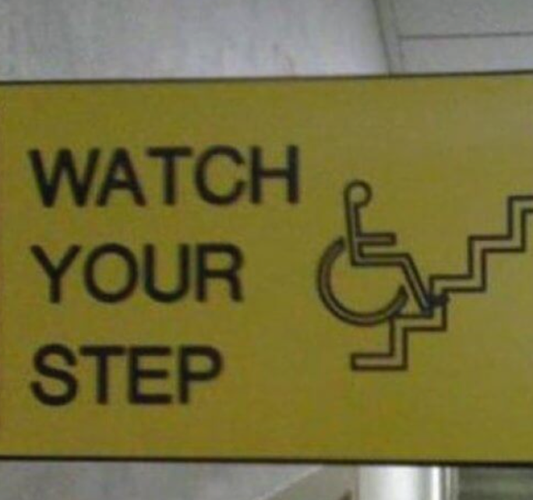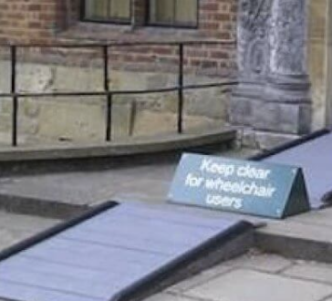

Part 2: Accessibility Education
So there's this need to build capacity, and urgently. What does accessibility education look like and how can we improve this?

Teaching accessibility in the digital skill set
OK, so my project is about investigating the teaching and learning of digital accessibility in academic and workplace settings to develop empirical research and research-led resources, enhance pedagogical culture and understanding, and foster dialogue between industry and education.
So this is about how tech designers, developers, computer scientists, product teams, people working on software and interfaces, the whole range of digital systems and platforms, learn about accessibility. It has resonance for all of us. We all make digital objects: files, spreadsheets, websites. We're all involved in that making.
So the thing that we've focused on is pedagogy. So I'm (here) in a great university, so I'm sure I don't need to tell you what pedagogy is. But as a little recap, pedagogy, because I'm from an education department, pedagogy is really about teaching in view of what we know about how people learn. And when we're researching pedagogy, there are different aspects. There's pedagogy as specified: this is the planned side, teacher values, their approaches, their strategies; pedagogy as enacted: teacher practice, what happens in class, activities, tasks and tactics; and then there's pedagogy as experienced, what the learner takes away. These are the three different dimensions that our research design has sought to explore. And we've completed expert panels, a range of focus groups, a lot of gathering around the data for that kind of confirmation, case studies at leading sites of learning.
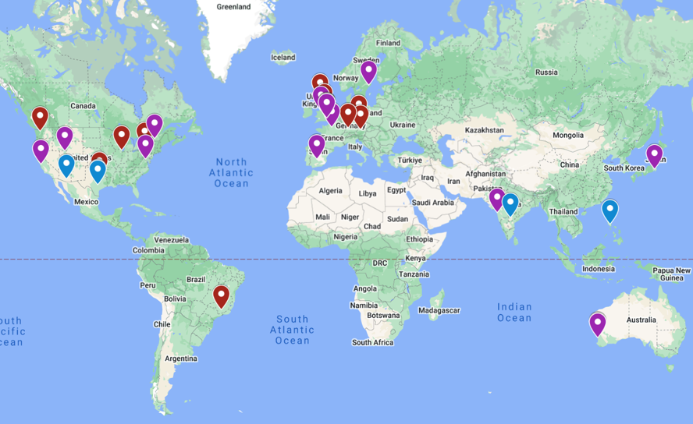
And I have a map onscreen with some flags across North America, Canada, Europe, Northern Europe, with flags also in India, Japan, across the world, highlighting some of the places that our experts have joined this research effort from.

Pedagogic content knowledge
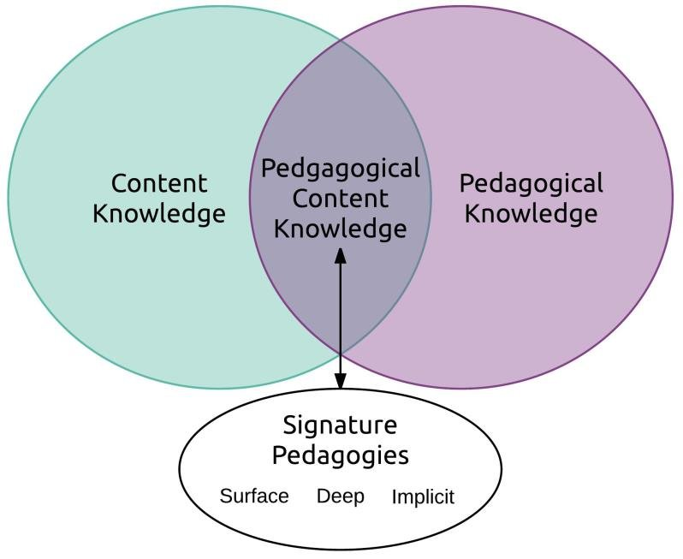 Diagram: Smith & Kanuka, 2018
So we're interested in pedagogic content knowledge. That is, not just the content, you know, the nature of accessibility, but bringing that into dialogue with pedagogical knowledge. And this is important, because that can be quite an implicit space, particularly for new and emerging fields. And one of the challenges of accessibility is that the people teaching it were not necessarily taught it themselves. We're kind of first generation. So we want to get away from that trial and error to help expand people's pedagogic repertoires, to help build, so everybody's not doing it from scratch every time.

Signature pedagogies
And what did we find? Well, we found some really interesting signature pedagogies, particularly around teaching with, through and about disability. So if you cast your mind back to earlier in this talk, I've been trying to position, and you probably recognise it, this recognition of disability as a site of expertise. There's been a lot about engaging with implicit and explicit models of disability, and also challenging technoableism and bias.
Again, this is a challenging thing, because this is quite an interdisciplinary effort that's taking place, often in very technical disciplines. And it's also challenging because, as we know as educators, we often like to draw on prior learning. It can be absolutely essential to taking your class as far as you can. But within this space, unlearning is often a key issue. We have to question what is already known. We have to make room for multiple ways of knowing, and decentre the student as the creator. So it's gaining that sensitivity to the unknown, to other ways of doing.

Pedagogic dissonance
And within some of the sciences – I don't want to cast grand aspersions, because there's a whole range of things that computer science and technical disciplines are – but there are these tensions, fundamental tensions, between the kind of human-centred, contextual, interdisciplinary and political nature of disability studies and human computer interaction, this part of accessibility that is so fundamental; and computer science, where there's sometimes that focus on logics, abstraction and tool orientation that can be actively anti-political: That question 'Why are you talking about disability and models of disability in a computer science classroom?'

Accessibility pedagogy
Now, obviously, we've come a long way over the last few years, but there are these tensions in certainly what students expect, and what they receive. So accessibility pedagogy integrates a range of dynamics: these conceptual understandings, disability models, notions of rights, justice, the procedural knowledge that constitutes the doing of accessibility.
So this is about prioritisation, interdisciplinary working, cross-role activities, prioritisation. Did I say prioritisation twice? Prioritisation is really important, so I will prioritise it for you again! And there's also this question of technical skills, of course, the actual – what does it look like to make an operating system work with a screen reader, what does it mean for that to interoperate across a whole system?
And of course, this is also a kind of field that flows across different areas from design, through to development, through to usability; and working across that whole chain is also important. So there are a lot of soft skills about communication, language, sharing, understanding the perspectives of other people, because this is a shared endeavour. The idea that accessibility sits with one developer is long gone, thank goodness. It has to be woven through the development process. It needs ownership by product owners. It’s a team effort. And reflecting that in education is challenging.

Integrating the conceptual, procedural and technical
So to integrate these different types of knowledge, we see the use of transformative and critical pedagogies. We see the embodying and modelling of accessibility through teaching, teaching in accessible ways. (That's 'in accessible ways'. Did it come up all right on the captions? To be fair, I did say ‘teaching in accessible ways’, but these were separate words. [Audience: Yeah, it's got it!]) OK, so we see the use of self-directed and peer-supported discovery learning – letting people discover it, take ownership; and bridging this abstract political spaces, so scaffolding new perspectives, decentring.

Contextual challenges
But there are contextual challenges. Students can enter the classroom with a lack of disability awareness or engagement with accessibility. There are pervasive disciplinary and role-based cultures, which can sometimes be siloed, and creating projects that acknowledge the shared endeavour can be difficult. There can be this reliance on individual accessibility heroes, which is always a challenge, because that introduces precarity, and it can also be indicative of a lack of status. So that single accessibility hero model, you know, if you're finding yourself in that position – it's a known factor – branching out, making allies, is so important. And then there's the time and resource. If you have to take a group of people with little experience of disability and take them through the social model and into what accessibility is in a one-off lecture, that's a big challenge: making learning stick. So there has to be the resource. And resource is sometimes an optional module, which again, might mean you have more engaged students, but it signals to the rest of the group that accessibility is optional. So there are these big challenges.

Implications and research trajectory
The implications going forward are about developing pedagogical culture. And I want to highlight some exciting things that have been going on. With my project, we try to spur this. And one of the things we've been lucky to do is work with the European Disability Forum, and Teach Access, which is a US initiative, to start to spur Teach Access Europe, which is a collection of universities, businesses, and advocacy organisations in a nonprofit trying to collect curricular resources, give students and teachers – teachers particularly – the resources to teach in a range of different subjects. Of course, Europe is a different context. We may have different priorities. So we're getting started with this, but it's an interesting initiative and I urge you to check it out.
We have the Southampton International Symposium on Teaching Accessibility. The next one's in January 2027. Again, a chance to bring people together to focus on teaching specifically. And there's been activities like special issues and so forth. And as a university, there is also for organisations, the Nicosia Declaration, which colleagues in Europe have led on, which allows universities to make statements about what their ambitions are, recognising excellence in accessibility and committing to it.
I realise there are various badges which we have in our EDI work around disability employment and so on, but with accessibility – we look at maybe the thresholds that we're assessed against – but these are a floor, not a ceiling. So this is an opportunity to demonstrate a commitment to excellence.

Part 3: The crossroads: accessibility and AI
Right, cracking on now. The crossroads! What about accessibility and AI? Because we get to this point, and then I'm developing the projects, and then I realise there's this crashing wave of something coming into this space [AI]. What does this mean? So we've been starting to look at AI and accessibility, what it means for professional skills, what it means for practice. So we're asking two key questions. How is AI impacting accessibility and accessibility work? And how does AI influence our understanding of accessibility skills? These are critical questions to ask early.
So we run workshops. I have reports down on the table if you're physically here and you like an analogue read. I know some of us like to touch things that are physical occasionally. [Links to reports are in the References of the Transcript.] So our first workshop was assessing the influence of AI on practice, and trying to establish those skills that we can't afford to lose, maintaining human in the loop. And our second has gone into a more critical space, engaging disability theory very actively as well, to look at speed, scale, compliance and regulation, and how we mitigate AI risks and harms. This is to ensure disability rights and user expertise. Now, it's developmental work, so it's ongoing. But there are a range of important issues that this raises.

AI-generated accessibility
So, AI-generated accessibility. There are these ways in which AI is supporting accessibility work. We see the assistive capacity of AI particularly is proving important. For example, we have the captions running. I know Microsoft has actively looked at working to engage disabled voice in improving their captioning to really step it up. And I think we're seeing the benefits of that. So there are these ways in which AI is helping in this assistive space. And we see improvements in alt text generation. There's of course programming code generation. If you're using coding environments, you know, you can now get accessibility widgets built in, which will look at your code, give you those opportunities to improve. And there's also user persona development, as well as the testing and evaluation aspects.

Can accessibility be automated?
But there is this question that haunts me. I know in every AI talk, we sort of pull between 'it's brilliant' and 'the world's going to end'. So where do I find myself on that scale? There are issues. And one is this question of averages. Because averages give us an idea of normal. So, with exceptions, generalised AI learns from dominant discourse. So we looked at all those web pages that were failing. That's the data that a lot of AI is trained on. This is a kind of a reflection of our world. It's not lived experience. And with that kind of hierarch – hierarchisation. [Turns towards the captions on the screen, and addresses the captions] Good luck with that [laughter]. It did! Oh, my goodness! OK, for those listening in who can't see, yes, the captions managed to capture 'hierarchisation' [laughs].
So when we have this risk of particular ways of knowing, ways of thinking, being encoded in the technologies that then reflect back to us and inform what we do next, there's this kind of compounded exclusion that can occur. And even within accessibility discourse, we see norms. You know, in any given situation, there are hierarchies that occur that might benefit some groups more than others. So in web standards efforts, there's been a particular push to recognise cognitive accessibility, because this was this was missing for a long time.
Compliance does not equal genuine inclusion necessarily. And there's this quote from Professor Jutta Treviranus at OCAD, who says this, and this has informed, I think, some of our thinking going into this. 'AI is not transformational in the direction it is taking us as a society. It is a statistical replicator, amplifying and automating existing patterns... To be truly transformational, we need to invert AI so that it optimises diversity.'
So there are technical ways to look for marginal data to address and get into this. But there is this risk of, I think also, this existential issue around potential algorithmic ableism. So if disabled people are the engine of accessibility knowledge, but we rely on AI for accessibility, we're severing the feedback loop that allows our field to move forwards. New knowledge is not being generated about disabled experience to allow us to continue to improve.

Acceleration
There's also acceleration, and the question of whether accessibility can function at the speed of AI. If AI enables ten times, 100 times productivity gains in the code generation – and we are seeing this ramping up of coding, of productivity in that space – to keep a human in the loop, manual accessibility testing becomes potentially a bottleneck. And there's this question of the temporal mismatch between the speed of AI, speed of accessibility, and speed of lived experience. There are also challenges, particularly for communities that are operating in different modalities.

AI and British Sign Language – risks and opportunities
So one of the people we've invited to inform our workshops was Tim Scannell, a Deaf accessibility consultant. And he was very concerned about the amount of sign language interpretation that was being pushed forward, automated sign language interpretation. Which he found robotic, was not accurate, and also not checked. So he was pushing very hard: this question of recognising who's being included, who's being left behind.
And maybe some of the traditional hierarchies of impairment and disability that we seek to address are being slightly reorganised by this technology. So there's a real need to look at who's being left behind. So true accessibility is inclusion in design. It's co-design. And his point is that AI must support respectful, community-led communication.

Futures
The next area that's also useful to consider is this question of ‘futures’. And we brought Professor Hannah Morgan, who looks at futurity – futures – to question what futures we're being given at the moment. And her work thinks about how talk about the future informs what we believe we can do now, how thinking about the future impacts our present. And she says 'The question is whether digital accessibility expands the range of imaginable futures for disabled people, or whether it primarily facilitates participation within predefined futures'. So what is this talk about AI doing to our notion of our own place in the world? Is it expanding our options, or do we feel like future has already been written, that we have no stake in it, that it's a done deal? And I think being quite critical about that is really helpful to regaining our ideas about what's possible, and recognising who's missing in our discussion of the future.

Access relationships
There's also the secondary – I don't want to say secondary – ways in which AI has a cascading impact for the real world. And I want to talk about access relationships. So if you know the work of Dr. Louise Hickman, she's done a lot – a great recent report called BSL is Not for Sale – And she has a new project called ‘The Algorithmic Kitchen’, which is about how disabled people can inform health technology through co-design, this kind of approach. She's also looked a lot at procurement. And her question relates to access relationships. So what is the impact on access workers? We were talking about interpreters, personal assistants, classroom assistants. And often this kind of labour is quite invisible. It's deeply relational, skilled work between people. And when you're working with access workers, they have an ability to recognise nuance in a situation. They can spot misunderstandings. They can intervene. So if, for example, you're in a doctor's surgery with an interpreter, a British Sign Language interpreter, and there's a misunderstanding, they'll spot it, they can give clarifications and so on. If you're reliant on an automated translation, then things can go wrong. And if we're talking about health settings there's a range of different settings where some of this is very high stakes. So the nature of access work, I think, bears consideration.

Directions
And then there's this question of directions. So Henny Swan's a co-director of Tetralogical, an accessibility consultancy, and she talks about – well, I'll read the quotes. She says, 'It's less directional, it's less predictable, AI literally accelerates production. It introduces variability where once we had stability... and it distributes responsibility further across vendors, systems, teams, and also governance and compliance.' And in discussion, it was clear that this is another area of potential existential threat to accessibility, because in some of her work she's encountered people working on the idea of probabilistic interfaces. This is the idea that an interface is not stable. When you go to a website currently, it's a deterministic resource. Every time you go there, it's going to look the same. Maybe with some tweaking on the basis of what you bought last week [laughter]. So there's scope for change, but the nature of the interface is stable. And we can assess that. We can assess it for accessibility. If we move into probabilistic interfaces, where you state what you want and it [the interface] brings a range of different things that change each time you visit the site – and obviously, if you've used AI, you may have tried this, you've asked the same question maybe twice, and you've got a very slightly different response – this question of, and I don't believe it's happening yet, but probabilistic interfaces, is diametrically opposite to how we currently safeguard accessibility. So there's a question of what does that mean for the standards work that we've built?

Community knowledge: the accessibility commons
And this is one of my key bugbears, which is about community knowledge. So we're all here and we're sharing community knowledge. There'll be a Q&A, people coming together, people thinking about things and developing things. My concern is about enclosure. This notion comes from social media research, which describes how public spaces online began to be enclosed, become walled gardens like Facebook and so on. And with that are introduced a range of issues, maybe about data and surveillance, maybe about accessibility. If we all begin to work only within AI as our route to access information, through questioning and so forth, there's a risk that as accessibility professionals develop their expertise, the questions and debates they used to have, in shared online spaces – so you might have email lists, there's a Slack channel, there are a range of places accessibility experts meet – if that becomes displaced by these online proprietary AI, we lose tacit, experiential knowledge, we lose this peer-produced nature of accessibility as a field that moves forward. So enclosure, I think, is a major issue.

Part 4: The future we build
So I'm onto my last part. I'm just about on track in terms of time. Looking to the future, what might this mean for what we do? In my title, 'Digital Accessibility at the Crossroads: Infrastructure, AI and the Future We Build', here's the crossroads metaphor. You know, the idea we might go one way or another. But I think it's possibly more useful to think that the future is not determined, it's constructed. And in a sense, we are in the building site. So how do we together safeguard our communities of practice, our relationships with our students, our peers and each other, to continue to build expertise, to continue to build accessibility? Well, from our workshops, we have some initial messages. There are skills to build and maintain, very human skills: curiosity, empathy, creativity, community building, and visionary thinking. There's this conversation about how some of our human activities could be supercharged through collaboration with AI. And there are these future-ready skills too: about ethical leadership, communication and tech fluency. We need to maintain our critical thinking, because AI is not the same as judgment. And there's also this need to understand users and understand ourselves and each other as well as maintaining the techniques of accessibility evaluation, so that isn't lost in this idea of an automated future. So, I put it to you that accessibility is a shared endeavour.
And I love this quote from Emma Sheppard at the Open University, who talks about access and disability justice in academia. She says access can be an act of 'joyful collaborative responsibility'. And I feel the joy at events like this. It's so great to have these opportunities to come together. She notices structural inequalities, but also of course, in academia, we are that structure. So there’s always the work that we need to do. And the great thing I think about disability studies as one of the most profoundly human subjects is that it gives us a range of conceptual tools that we can apply at this moment. The first is access as infrastructure. Accessibility is not accommodation, it's foundation. We see disability as expertise, that is, lived experience is knowledge, not deficit. Some of you have encountered the notion of ‘crip time’, which considers how experience of time as a disabled person is deeply human. And I think there's a great deal there for us to use in terms of considering human time when we're facing this kind of capitalist acceleration and productivity. And there are also theories about hierarchies of impairment. This comes from Mark Deal's work. It's useful because it allows us to notice the priorities that we are encoding by [instead] asking ‘Who is missing here?’. And Deal suggests we attend to the most excluded to create more robust and safe solutions for everybody.
And when we think about hierarchies of impairment and the social, the cultural, the contextual aspects of that, we can see how these hierarchies are reconfigured and changed in different circumstances. So, for example, you know, COVID changed the nature of these hierarchies – who was most at risk, what inclusion and equity meant – and still has knock-on aspects today.

Higher Education contexts
So for higher education contexts, the role of AI in teaching, assessment, student support, digital content, administration and procurement raises a whole thorny range of issues. I don't have all the answers. But one I think is about ensuring that accessibility and inclusion are there in the conversations about AI, that they're recognised in AI strategy and competency frameworks. Some of that might be about risk assessment, but it's also about who's at the table in that decision making. There's the importance, of course, of developing AI literacies and institutional support. But I think I, and possibly others in this room, responded recently to the Government consultation on their Digital Inclusion Action Plan. And within that, there was a lot of talk about getting people online, giving them the skills and so on, which is great. But there was nothing about helping people as they learn those skills to understand how to develop accessibility to ensure they're not locking out the people behind them. So there's this kind of missing piece sometimes in terms of recognising accessibility within the training, within the literacies, seeking to mitigate risks of widening digital inequalities, and of course, including disabled staff and students in decision making.

Preliminary policy recommendations
So we have preliminary policy recommendations. I have copies of the report, as I mentioned, and anybody online who would like a copy, just get in touch and I'll share it, of course. [Link to report in References.] The recommendations centre on human-centred AI, embedding accessibility and inclusivity; of course, involving disabled communities in co-design, development, and policy; and of course, backing regulatory frameworks and standards for ethical and responsible use. These standards come from us, communities and real people, and they have value. So when we want to know, when we want accountability, transparency, this is how we're going to get it, if we're going to get it.
There's also the need to professionalise AI competencies with skills development in critical evaluation, and this issue of shared practice and collaboration. Because as I've mentioned, I think we're at a moment where we are being pushed apart by technology. So affirming that connection, coming back together, becomes a political act. The personal is political within this. There you go. Thank you very much, everybody.

Vote of thanks by David White, Chief Digital and Information Officer
Good evening, everyone. As you've just heard, I'm David White. I'm the University's Chief Digital Information Officer. And it falls to me to bring our fantastic event this evening to a close. I'm aware that I'm the one thing standing between those of you in the room and the refreshments outside. So I'll keep my comments brief.
My reflections, I think, from this evening are twofold. The first Sarah, how integrative, how integrated your way of thinking is. I think in my experience, when I talk about AI or about technology and the challenges that it faces in our society, it often feels like a world of polarities, as the world in general increasingly does. And what I found so inspiring about your talk this evening was the perspective you bring that actually if we do that, we risk just looking at the average or the default, and that I think a more integrated integrative model of approaching these things to draw in different perspectives and think about how we can be better is something I'll certainly be carrying away with me from this evening.
And I think the second is actually the space for ambition here. I think when I talk about accessibility, I'm fond of saying that it shouldn't be an add-on, and I think that's important. But actually, I think you've encouraged me to be more ambitious than that. I loved what you had to say about innovation, the way in which disability and accessibility can be spaces for that kind of work. And also your use of the word ‘joy’. I think there's joy in this space, and I find that so inspiring. So we carry the weight of the world on our shoulders these days, but I will be leaving with a spring in my step from this presentation.
I want to say a few words of thanks to those of you on the Disability and Neurodivergence Advisory Group. Thank you for your work in organising this evening's event. Thank you to those of you in the Equality and Diversity Unit for your support for the Advisory Group as well. Congratulations on twelve years of fantastic events. I think this evening's event shows how vital and necessary, relevant, this event continues to be and look forward to the next twelve years of disability here at Oxford. I'd like to thank all of you in the audience here and online for your participation this evening, your contribution in such thoughtful and stimulating questions.
And last, and certainly most importantly, I would like to thank Doctor Sarah Lewthwaite for her fantastic presentation this evening. Please join me. [Applause] And thanks, thanks indeed to our online signers for the excellent work and no doubt tiring work you've been doing this evening. As I said, I'm standing between you and refreshments, so please join us outside if you're in the room this evening for drinks, and if you're online, raise a can of pop to us at home. Thank you.

References
Coverdale A, Lewthwaite S & Horton S (2024). Digital Accessibility Education in Context: Expert Perspectives on Building Capacity in Academia and the Workplace. ACM Transactions on Accessible Computing.
Coverdale A, Lewthwaite S, Elglaly Y N, Hollier S, Horton S, Sonka K & Zimmermann G (2024) Editorial: Advancing digital accessibility in academic and workplace education. Frontiers in Computer Science. V6.
Gordon A and Lewthwaite S (2 Feb 2026) Why digital accessibility is now a leadership issue for universities. Times Higher Education.
Lewthwaite S and Coverdale A (2026) AI and accessibility skills: building the accessibility professional of the future (Insights from the first AI and Accessibility Skills Workshop). Report published by the University of Southampton and JISC.
Lewthwaite S and Coverdale A (2026) Critical approaches to AI and accessibility capacity building. (Insights from the second AI and Accessibility Skills Workshop). Report published by the University of Southampton and JISC.
Lewthwaite S, Horton S and Coverdale A (2023) Workplace approaches to teaching digital accessibility: establishing a common foundation of awareness and understanding. Frontiers in Computer Science (Vol 5).
Malazita J W & Resetar K (2019) Infrastructures of abstraction: how computer science education produces anti-political subjects. Curriculum Inquiry 30(4), 300-312.
Nind, Curtin & Hall (2016) Research methods for pedagogy. Bloomsbury.
Nind, M., & Lewthwaite, S. (2019). A conceptual-empirical typology of social science research methods pedagogy. Research Papers in Education, 35(4), 467-487.
Shulman, L. (1986) Those who understand: knowledge growth in teaching. Educational Researcher, Vol. 15, No. 2.
Smith. E. E. and Kanuka, H. (2018) Transdisciplinary or pedagogically distinct? Disciplinary considerations for teaching certificates. International Journal of Teaching and Learning in Higher Education. 30(3), 388-401.
Synder et al. (2019) Unlearning through Mad Studies: Disruptive pedagogical praxis. Curriculum Inquiry 49(4), 485-502.

Resources mentioned in the transcript
The Algorithmic Kitchen
Against Technoableism
BSL is Not for Sale
Centre for Research and Inclusion at Southampton
Digital Inclusion Action Plan
Disability Discrimination Act 1995
Equality Act 2010
European Accessibility Act 2025
European Disability Forum
Nicosia Declaration
Public Sector Bodies Accessibility Regulations 2018
Teach Access Europe
Web Content Accessibility Guidelines
WebAIM Million

Contact details
Email: s.e.lewthwaite@soton.ac.uk
Website https://TeachingAccessibility.ac.uk/

